SI Addendum 2

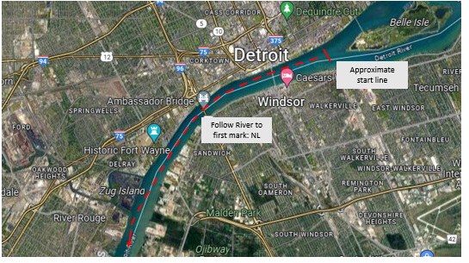

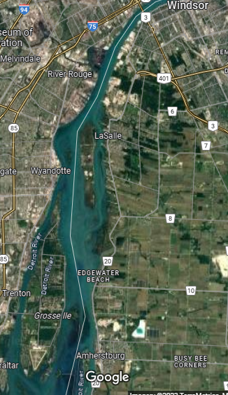

NL

Grassy Island

SL

UEL

D65

DL20

RN16

Finish